7-15-2011

In this week’s issue of college central we tell you of an outstanding star Anthony Rendon and what college baseball team had head scratching surprises.

[Year]
ACSD
Aiken County School District
[Pick the date]

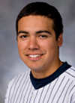 In the year 2011 there was a lot of talent in the college baseball league. One of the players that stood out the most was Anthony Rendon (Rice).Rendons home town is Houston TX. In high school he won many awards for his achievements. After taking an injury he was able to come back with a huge year. He was an infielder who batted right handed and threw right handed.
Playing for Lamar High School Anthony Rendon had an amazing senior year. He batted with a .570 average, 8 homeruns, 17 doubles, 56 RBI, 56 runs scored, and 13 steals. After high school he played for Rice. Rendon made a great first impression starting all 61 games while hitting with a .388 average, 20homeruns, 72 RBI and a .702 slugging average.
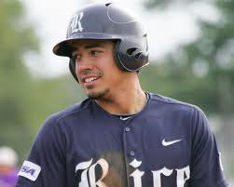 In his career he won many awards that no other freshman had. He was the first freshman in the Conference USA to ever win freshman of the Year and Player of the Year awards. . He also received several national awards including being named Second Team All-American by Baseball America and NCBWA, 2009 National Freshman of the Year by Collegiate Baseball, and a member of the 2009 NCBWA Freshman All-American team.
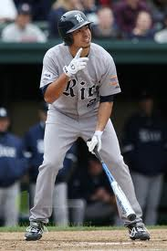In the 2009 super regional against LSU he had a major ankle injury which made it were he couldn’t play during the summer. After recovering he would come back and have one of the best seasons in college baseball in 2010.He hit .394, he had 26 homeruns while driving in85 runs. He was named the consensus player of the year in 2010 by picking up the Dick Howser Award and Baseball America’s Player of the Year Award. Rendon suffered his second major ankle injury during the first game of International play with the USA Collegiate National Team which ended his summer early.
In conclusion everybody at College Central agrees that Anthony Rendon is an outstanding player and has a very bright future to look forward to. Some of you might ask where Rendon is now. Third baseman Anthony Rendon begins a rehab assignment that will reportedly last about a week with the Doubleday’s as he continues to come back from an ankle injury suffered in April. Rendon started his comeback with the Gulf Coast League Nationals last week and was 4-for-11 with two home runs and six RBI in five games. Rendon ranked as Washington’s top organizational prospect since Bryce Harper was called up to the Nationals.

Sources:
http://auburnpub.com/sports/doubledays/anthony-rendon-nationals-top-prospect-will-play-in-auburn-update/article_c3f9af7c-d6a7-11e1-80f9-0019bb2963f4.html
http://www.collegebaseballdaily.com/2011-season-coverage/2011-top-100-college-baseball-players/

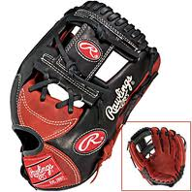
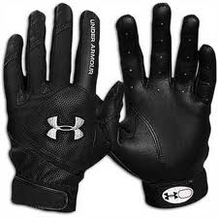

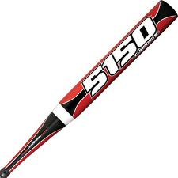

Many teams in college baseball have let downs but not just one player let downs, but a whole team has a letdown. Like starting the season with a bad record like New Mexico and Sad Diego this can be very bad for the entire season.
New Mexico had one of their best seasons in over 50 years in 2010.But this year things aren’t going the same as last year. After earning the programs first NCAA bid since 1962, the 2011 Lobos are off to a 9-20 start. There season started with the first 8 games lost. Many players came back from the 38-22 season in 2010 but they are still having troubles winning. The New Mexico has always been an offensive team but this year there average dropped 80 points from last year’s .346.The on base also dropped 70 points to a .342.The lack of a constant offensive with a combined 6.05 ERA has been nothing but disaster so for knowing he was going to have a hard season he still schedule his team to play a rough teams like Arizona State, Oklahoma State, Arizona, and Oklahoma.

