Art 1 Research Presentation: Famous Artist
http://www.biography.com/people/paul-cezanne-9542036
http://www.wisegeek.com/who-is-paul-cezanne.htm

Paul Cezanne
- Born January 19, 1839, in Aix-en-Provence.
- Died October 22, 1906, in Aix-en-Provence.
- His father, Philippe Auguste, was the cofounder of a banking firm that prospered throughout the artist's life, affording him financial security that was unavailable to most of his contemporaries and eventually resulting in a large inheritance.
- entered the Collège Bourbon
- dad want him to be in law school instead of an artist
- Gardanne ---- 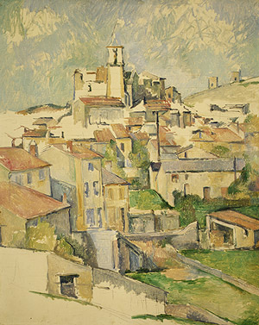
- Art Movement is Post-Impressionism
- He married in 1886 and had one son, Paul Cezanne, Jr.
